V-Electronics: Revolutionizing Smart Device Management

**Phase 3: Data Modeling & Relationships**

With the Salesforce environment configured in Phase 2, the next step in the **V-Electronics Project** was to design the underlying data architecture. This phase was dedicated to building a logical and scalable model that could represent the organization’s business entities (customers, products, and orders) and their interrelationships.

A robust data model ensured that the system could store, retrieve, and manage information accurately while supporting reporting, automation, and integration needs.

**1. Introduction**

In Salesforce, data modeling involves creating objects, fields, and relationships that mirror real-world entities. For V-Electronics, this meant setting up objects such as **VCustomers, VOrders, and VProducts**, and defining how they interact with one another.

The data model was carefully designed to balance **simplicity (ease of use)** and **scalability (supporting future growth)**.

**2. Objectives of this Phase**

* To design standard and custom objects that capture essential business data.
* To configure fields, record types, and layouts for data accuracy and usability.
* To establish meaningful relationships (lookup, master-detail, junction objects) between entities.
* To leverage schema builder for visualizing and validating the data model.
* To introduce external objects where integration with external systems was required.

**3. Detailed Description of Contents**

**Standard & Custom Objects**

* **Standard Objects Used:** Accounts, Contacts, Opportunities for basic CRM functionality.
* **Custom Objects Created:**
  + **VCustomers** → captured customer details specific to electronics retail.
  + **VProducts** → tracked electronic products with specifications like warranty, price, and stock.
  + **VOrders** → managed customer orders and their fulfillment.
* These objects formed the **core entities** of the system.

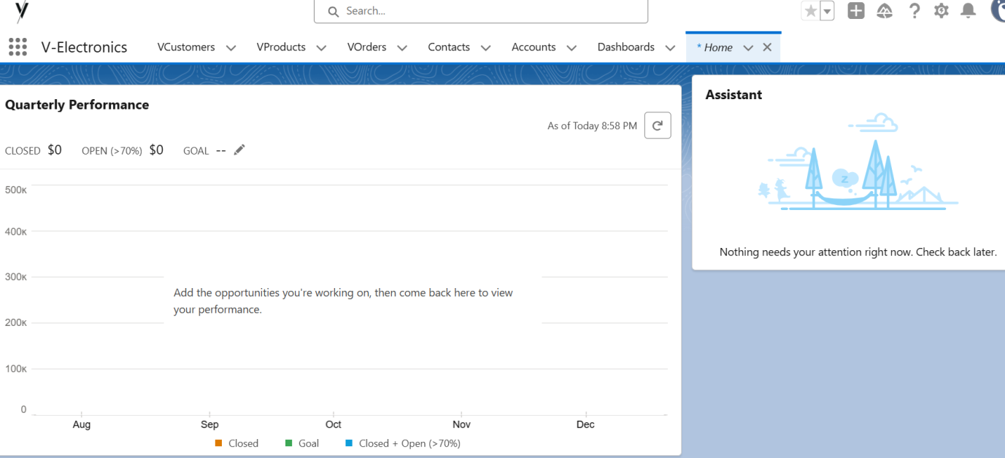

**Fields**

* Added **custom fields** to capture specific details.
  + Example: Full name(text),first name(text).
* Used formula fields for automatic calculations (e.g., Order Total).
* Applied validation rules to ensure field accuracy (e.g., warranty period cannot be negative).

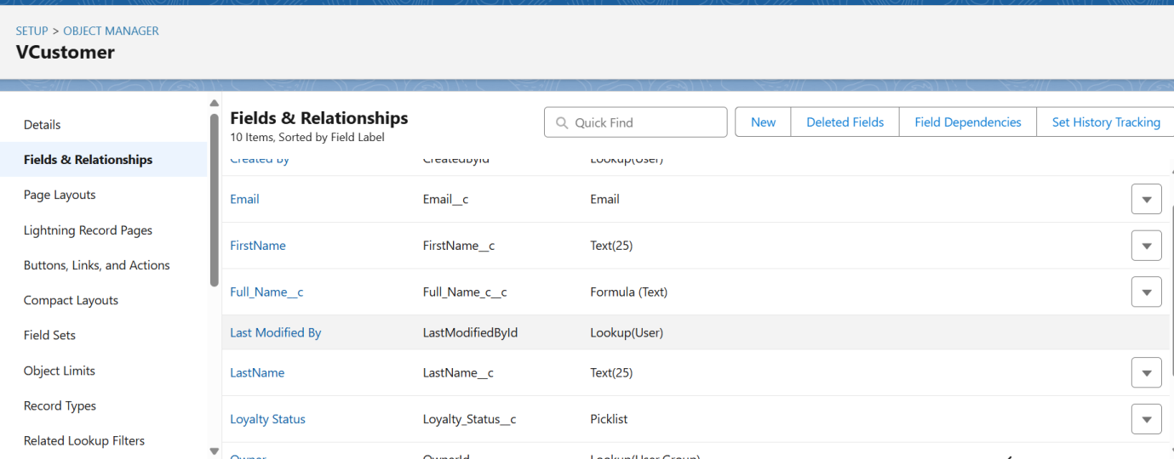

**Record Types**

* Created record types for handling variations in objects.
  + Example:
    - VProducts → Consumer Electronics, Home Appliances.
    - VOrders → Retail Orders, Wholesale Orders.
* Each record type had its own page layout for context-specific data capture.

**Page Layouts**

* Configured layouts to show relevant fields to the right audience.
  + Example: For Sales Agents, the Order Layout emphasized customer details and order status.
* Enhanced usability by grouping related fields together.

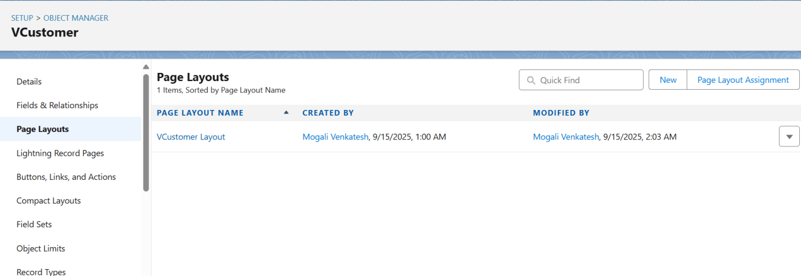

**Compact Layouts**

* Defined compact layouts for mobile users to quickly see key fields.
  + Example: For VCustomers → Name, Contact, Loyalty Tier.
* Improved the mobile experience for sales agents working in the field.

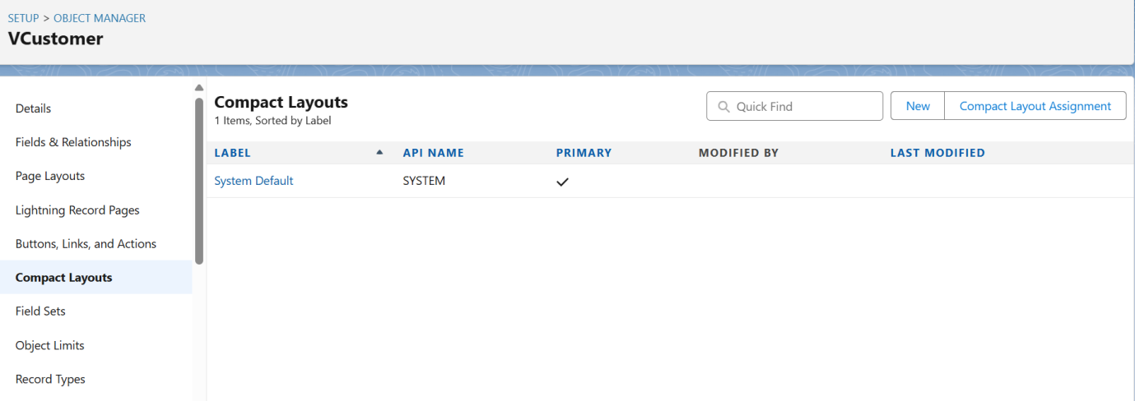

**Schema Builder**

* Used Salesforce Schema Builder to visually represent object relationships.
* This allowed validation of how VCustomers, VProducts, and VOrders were connected.
* Made it easier to communicate the model with stakeholders and technical teams.

**Lookup vs Master-Detail vs Hierarchical Relationships**

* **Lookup Relationships:** Used for optional, flexible links.
  + Example: Linking Orders to a Referring Agent.
* **Master-Detail Relationships:** Enforced strong ownership.
  + Example: VOrders → VCustomers (a customer owns their orders).
* **Hierarchical Relationships:** Applied within the User object to define reporting.

**Junction Objects**

* Designed junction objects for many-to-many relationships.
  + Example: **OrderProduct__c** object linked VOrders and VProducts to track multiple products per order.
* This enabled accurate order breakdowns and reporting.

**External Objects**

* Integrated external ERP data using **Salesforce Connect**.
* Example: Supplier inventory data was referenced as an external object, avoiding duplication while ensuring real-time availability.

**4. Deliverables/Outcomes of Phase 3**

* Defined standard and custom objects (VCustomers, VOrders, VProducts).
* Configured fields, record types, page layouts, and compact layouts.
* Established relationships using lookup, master-detail, and junction objects.
* Created a schema diagram via Schema Builder.
* Introduced external objects for ERP integration.

**5. Conclusion**

Phase 3 established the **data backbone** of the V-Electronics system. With a structured data model, the organization could capture critical business information and enforce relationships between entities.

This phase ensured data accuracy, scalability, and usability—serving as the **foundation for Phase 4 (Process Automation)**, where workflows and rules would bring this data to life through automation.